**Selenium Hands-on:**

**Day5 Tasks:**

**MouseHover Action:**

QUESTION:

----------

URL : https://www.shopclues.com/wholesale.html

NOTE: Mobile and electronics is first mouseover and click range Rs5001 - Rs10000

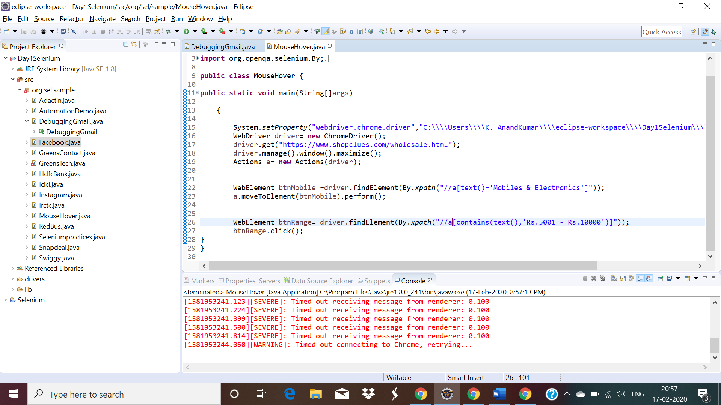

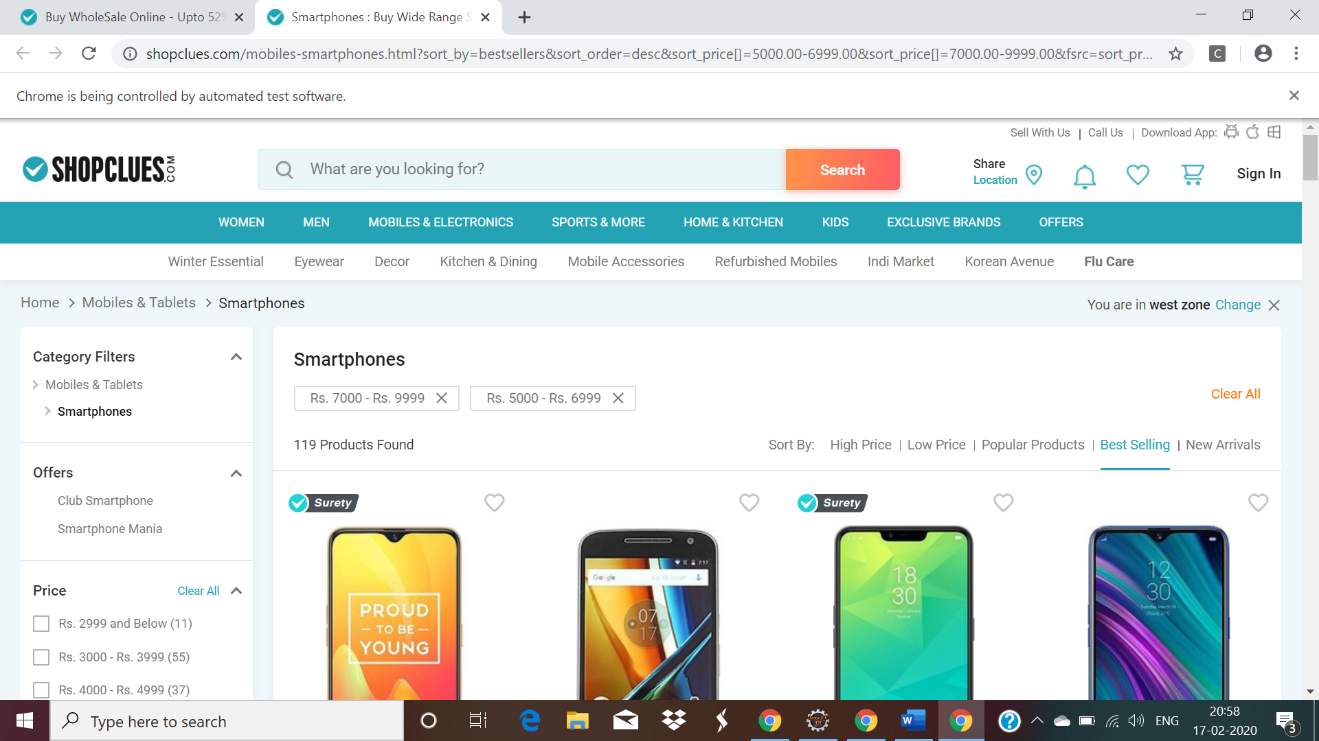

QUESTION 2:

----------

URL : http://greenstech.in/selenium-course-content.html

NOTE: Courses is first mouseover

DataWarehouse training is second mouse over

click microstategy training.

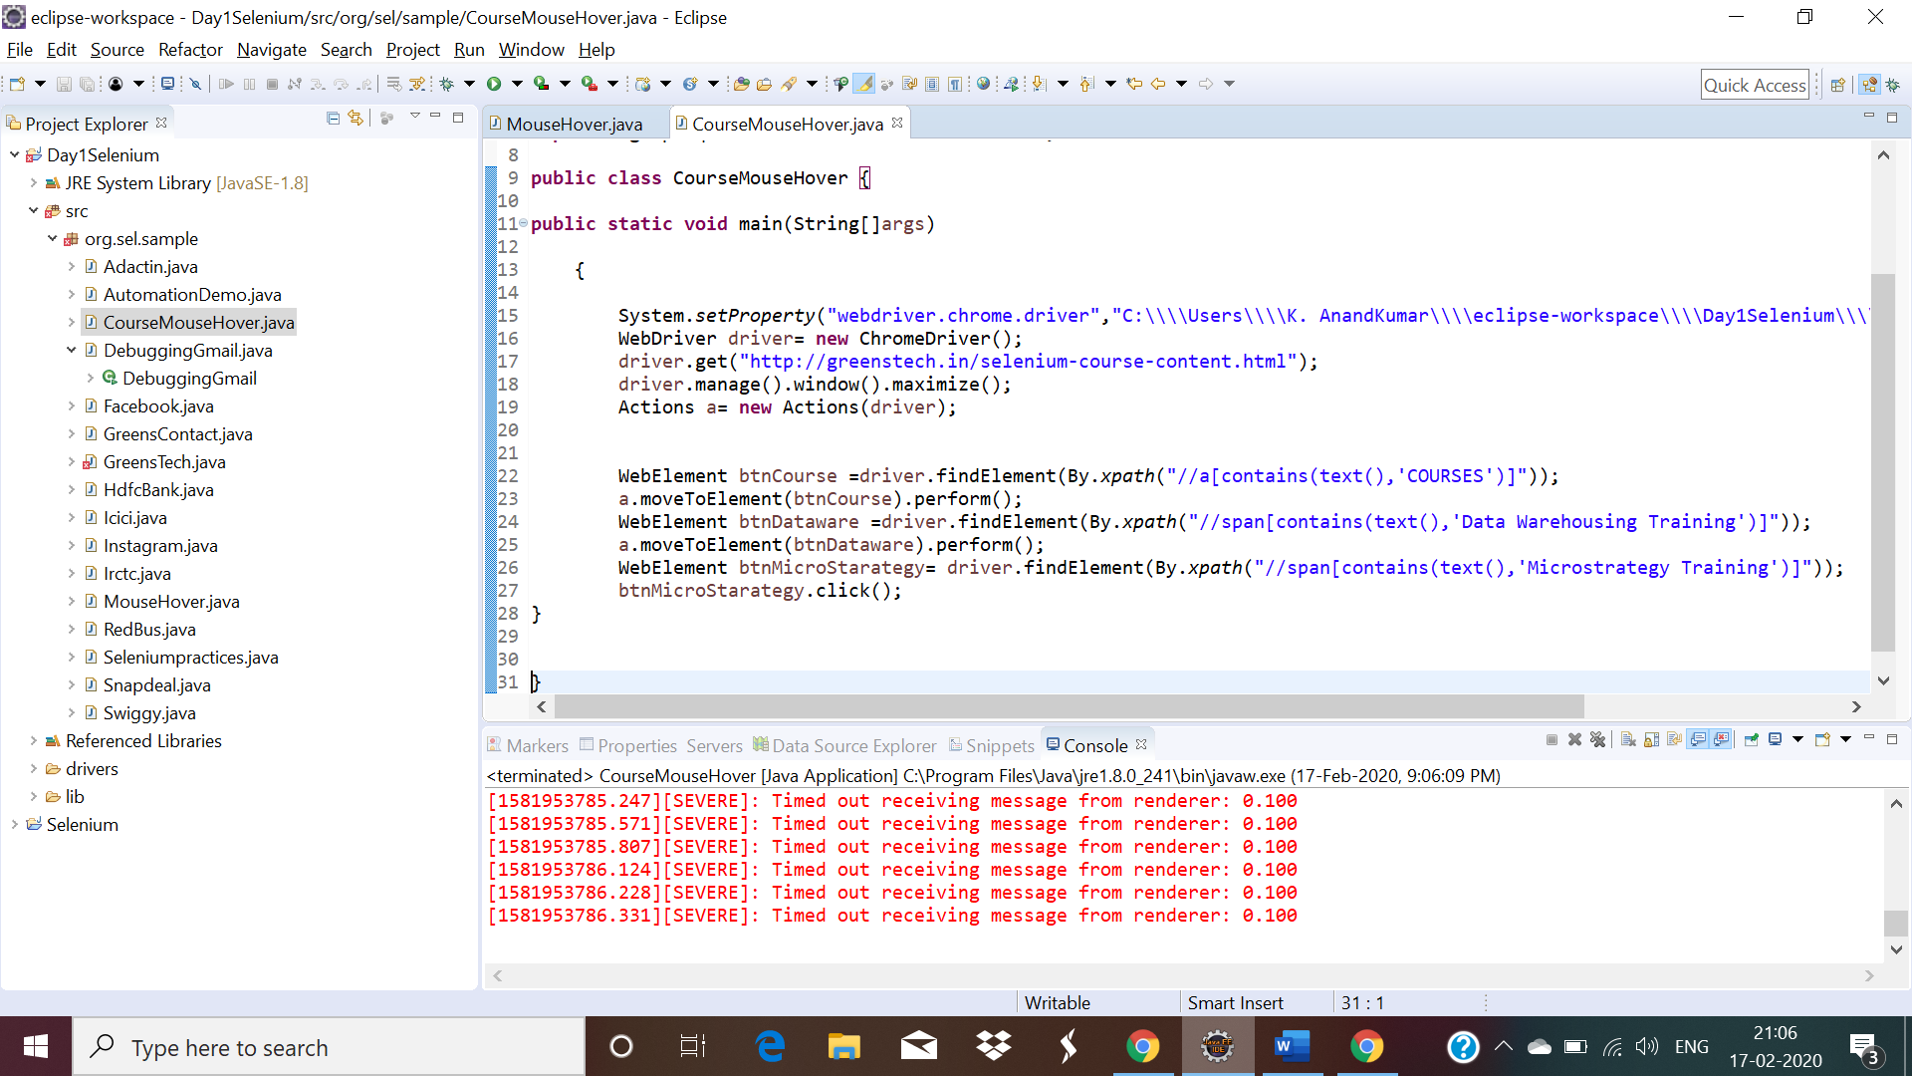

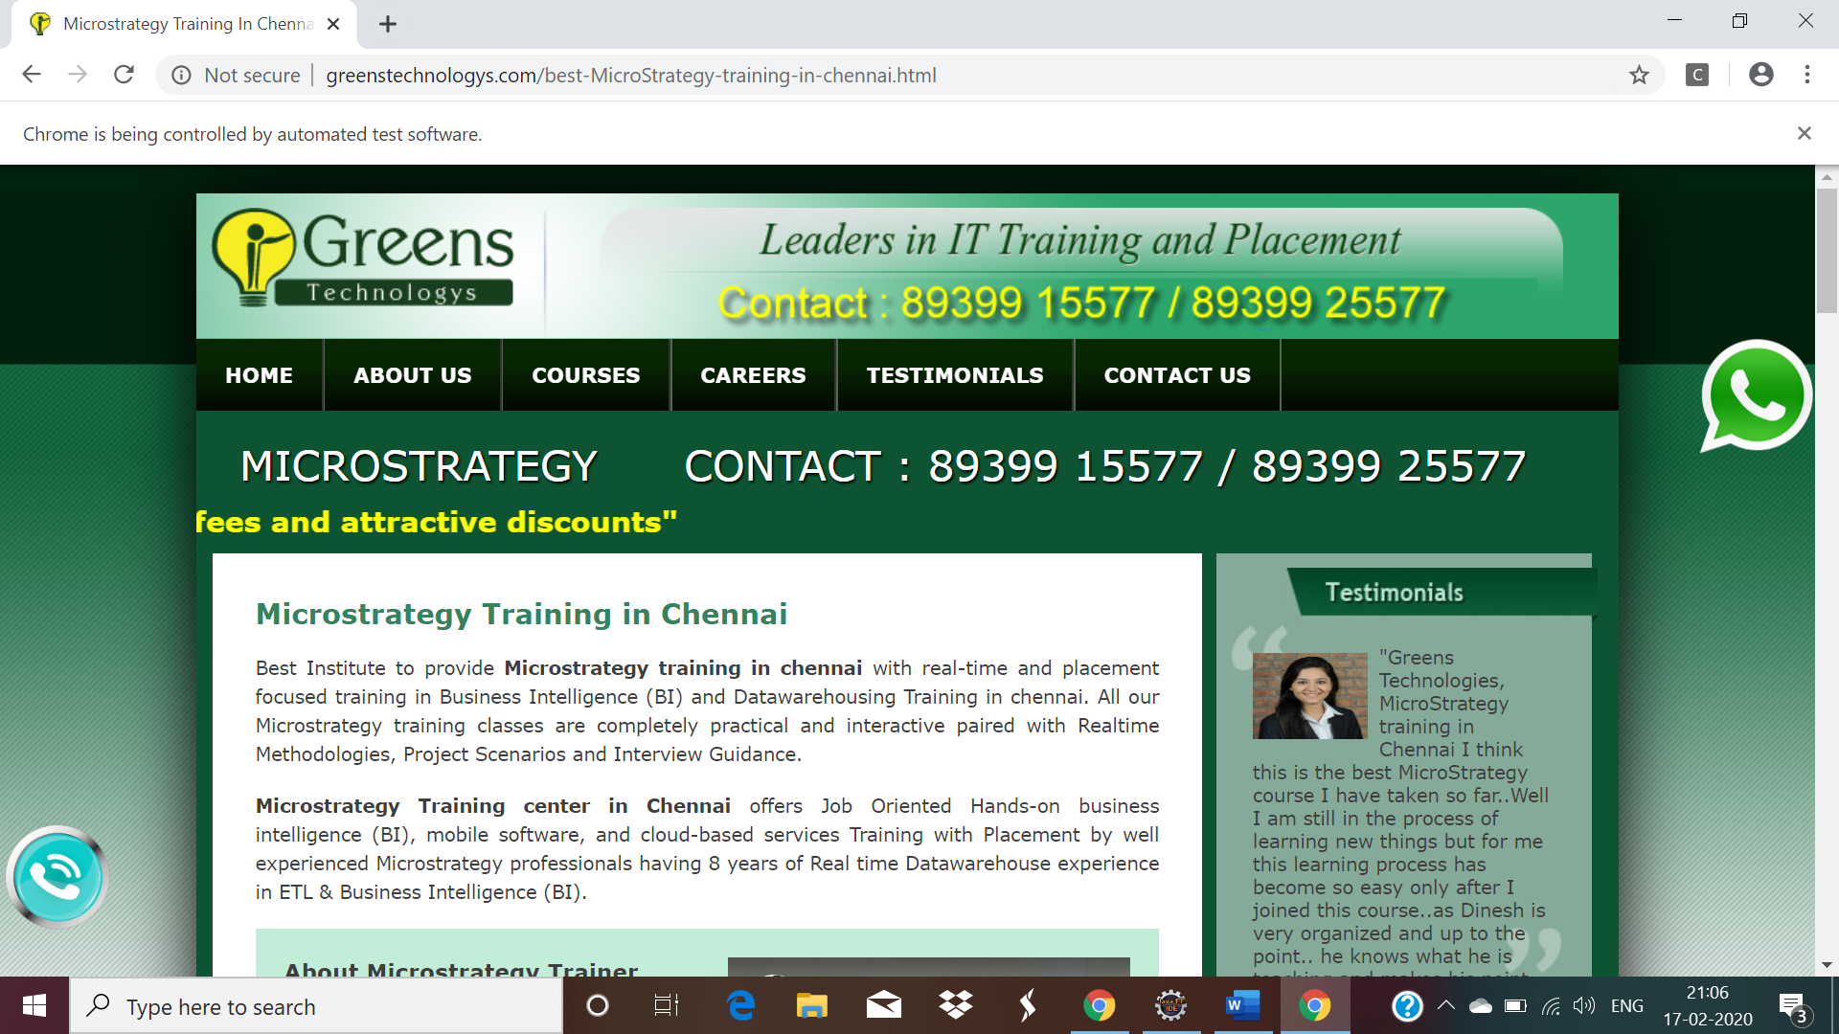

QUESTION 1

----------

URL : http://demo.guru99.com/test/drag_drop.html

NOTE: Drag bank ,5000 in debited side and drop sales,5000 in credited side

